Q1.Two figures given on the left side of (::) are related with some logic/rule/relation. Select themissing figure on the right side of (::) from the given alternatives based on the same logic/rule/relation
(SSC-GD-4th May 2026 SHIFT-3)
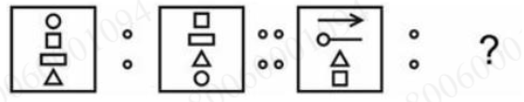
A.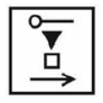
B.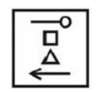
C.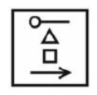
D.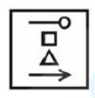
Ans:A
Exp:The Solution is
Analyze the change in the first pair (Left of (::)):
Looking at Page 3, the first box contains a column of three shapes: a square (top), a circle (middle), and a triangle (bottom), pointing upwards from a line.
In the second box, the inner shapes shift or change orientation. The vertical stack transforms into a horizontal alignment, and the arrow element changes positions.
Apply the exact rotation/shifting rule to the second pair:
The third box has a horizontal line with a circle on a pin pointing left, and a triangle at the bottom.
Rotating or flipping the orientation according to the first rule moves the horizontal line element to the bottom, pushing the square to the top and maintaining the relative positional inversion. This matches the exact orientation shown in option A.

Subject:Reasoning > Analogy
Difficulty:Medium
Q2.Two figures given on the left side of (::) are related with some logic/rule/relation. Select themissing figure on the right side of (::) from the given alternatives based on the same logic/rule/ relation
(SSC-GD-4th May 2026 SHIFT-3)
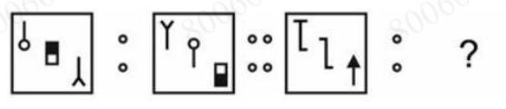

A.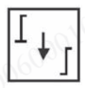
B.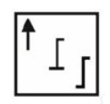
C.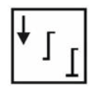
D.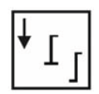
Ans:A
Exp:The Solution is
Analyze the change in the first pair (Left of (::)):
Looking at Page 3, the first box contains a column of three shapes: a square (top), a circle (middle), and a triangle (bottom), pointing upwards from a line.
In the second box, the inner shapes shift or change orientation. The vertical stack transforms into a horizontal alignment, and the arrow element changes positions.
Apply the exact rotation/shifting rule to the second pair:
The third box has a horizontal line with a circle on a pin pointing left, and a triangle at the bottom.
Rotating or flipping the orientation according to the first rule moves the horizontal line element to the bottom, pushing the square to the top and maintaining the relative positional inversion. This matches the exact orientation shown in option A.

Subject:Reasoning > Analogy
Difficulty:Medium
Q3.Two figures given on the left side of (::) are related with some logic/rule/relation. Select the missing figure on the right side of (::) from the given alternatives based on the same logic/rule/relation. (SSC GD - 6 MAY 2026 SHIFT 3)
A.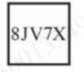
B.
C.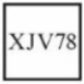
D.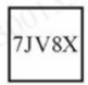
Ans:B
Exp:The Solution is
- Logic: Observe the shifting pattern of the 5 character positions from the first cluster to the second.
- Let the slots of 3A2B7 be numbered as [1, 2, 3, 4, 5].
- In the next step A32B7, the elements at positions 1 and 2 swap (3A becomes A3), while positions 3, 4, and 5 (2B7) remain identical.
- Applying this exact swapping rule to the first two characters of J8VX7: J8 becomes 8J, and VX7 remains exactly the same, giving 8JVX7.
- Correct Answer: B) 8JVX7

Subject:Reasoning > Analogy
Difficulty:Easy

Q4.Two figures given on the left side of (::) are related with some logic/rule/relation. Select the missing figure on the right side of (::) from the given alternatives based on the same logic/rule/relation. (SSC GD - 6 MAY 2026 SHIFT 3)
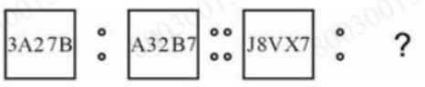
A.
B.
C.
D.
Ans:B
Exp:The Solution is
- Logic: Observe the shifting pattern of the 5 character positions from the first cluster to the second.
- Let the slots of 3A2B7 be numbered as [1, 2, 3, 4, 5].
- In the next step A32B7, the elements at positions 1 and 2 swap (3A becomes A3), while positions 3, 4, and 5 (2B7) remain identical.
- Applying this exact swapping rule to the first two characters of J8VX7: J8 becomes 8J, and VX7 remains exactly the same, giving 8JVX7.
- Correct Answer: B) 8JVX7

Subject:Reasoning > Analogy
Difficulty:Easy
Q5.Two figures given on the left side of (::) are related with some logic/rule/relation. Select the missing figure on the right side of (::) from the given alternatives based on the same logic/rule/ relation.
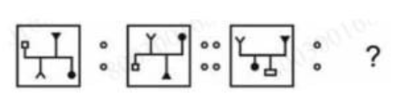
(SSC GD – 8 MAY 2026 SHIFT 2)
A.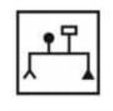
B.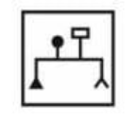
C.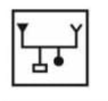
D.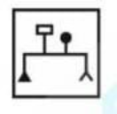

Ans:B
Exp:The Solution is
- Analyze the first pair: In the first box, the figure contains a central horizontal beam with vertical elements. When transforming into the second box, the entire structure undergoes a specific rotation and inversion where the branching pins and solid square/circle indicators shift position according to a fixed geometric flip.
- Apply to the second pair: Following the exact same spatial inversion rule, the third figure transforms into Option B, which properly mirrors the alignment of the branching top elements and the base weights.

- Subject:Reasoning > Analogy
- Difficulty:Medium
Q6.Two figures given on the left side of (::) are related with some logic/rule/relation. Select the missing figure on the right side of (::) from the given alternatives based on the same logic/rule/ relation.
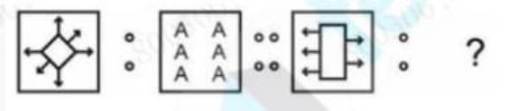
(SSC GD – 8 MAY 2026 SHIFT 2)
A.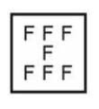
B.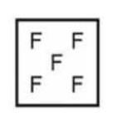
C.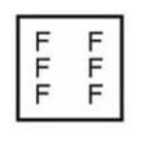
D.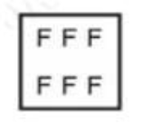
Ans:A
Exp:The Solution is
The total number of letter slots filled matches the bounding elements. If the first figure correlates 4 diamond lines + 2 inside elements to make 6 letters, the second block correlates 5 arrow lines + 2 vertical boundary sides of the rectangle to make 7 letters.
This confirms Option A with its 7 F's is the correct match.

Subject:Reasoning > Analogy
Difficulty:Medium
Q7.Two figures given on the left side of (::) are related with some logic/rule/relation. Select themissing figure on the right side of (::) from the given alternatives based on the same logic/rule/relation
(SSC-GD-4th May 2026 SHIFT-3)

A.
B.
C.
D.
Ans:A
Exp:The Solution is
Analyze the change in the first pair (Left of (::)):
Looking at Page 3, the first box contains a column of three shapes: a square (top), a circle (middle), and a triangle (bottom), pointing upwards from a line.
In the second box, the inner shapes shift or change orientation. The vertical stack transforms into a horizontal alignment, and the arrow element changes positions.
Apply the exact rotation/shifting rule to the second pair:
The third box has a horizontal line with a circle on a pin pointing left, and a triangle at the bottom.
Rotating or flipping the orientation according to the first rule moves the horizontal line element to the bottom, pushing the square to the top and maintaining the relative positional inversion. This matches the exact orientation shown in option A.

Subject:Reasoning > Analogy
Difficulty:Medium
Q8.Two figures given on the left side of (::) are related with some logic/rule/relation. Select themissing figure on the right side of (::) from the given alternatives based on the same logic/rule/ relation
(SSC-GD-4th May 2026 SHIFT-3)


A.
B.
C.
D.
Ans:A
Exp:The Solution is
Analyze the change in the first pair (Left of (::)):
Looking at Page 3, the first box contains a column of three shapes: a square (top), a circle (middle), and a triangle (bottom), pointing upwards from a line.
In the second box, the inner shapes shift or change orientation. The vertical stack transforms into a horizontal alignment, and the arrow element changes positions.
Apply the exact rotation/shifting rule to the second pair:
The third box has a horizontal line with a circle on a pin pointing left, and a triangle at the bottom.
Rotating or flipping the orientation according to the first rule moves the horizontal line element to the bottom, pushing the square to the top and maintaining the relative positional inversion. This matches the exact orientation shown in option A.

Subject:Reasoning > Analogy
Difficulty:Medium

Q9.Two figures given on the left side of (::) are related with some logic/rule/relation. Select the missing figure on the right side of (::) from the given alternatives based on the same logic/rule/relation. (SSC GD - 6 MAY 2026 SHIFT 3)
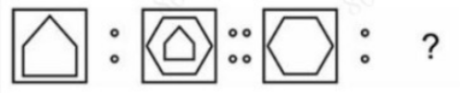
A.
B.
c.
D.
Ans:B
Exp:The Solution is
- Logic: Analyze the change in geometric shapes inside the boundary frames.
- First pair: A pentagon is placed inside a square. In the next image, a smaller inner duplicate pentagon is added inside it.
- Second pair: A hexagon is placed inside a square. Following the same rule, the missing figure must add an inner duplicate hexagon.
- Correct Answer: B (Hexagon with an inner duplicate hexagon)

Subject:Reasoning > Analogy
Difficulty:Easy
Q10.Two figures given on the left side of (::) are related with some logic/rule/relation. Select the missing figure on the right side of (::) from the given alternatives based on the same logic/rule/relation. (SSC GD - 6 MAY 2026 SHIFT 3)

A.

B.

C.

D.

Ans:B
Exp:The Solution is
- Logic: Observe the shifting pattern of the 5 character positions from the first cluster to the second.
- Let the slots of 3A2B7 be numbered as [1, 2, 3, 4, 5].
- In the next step A32B7, the elements at positions 1 and 2 swap (3A becomes A3), while positions 3, 4, and 5 (2B7) remain identical.
- Applying this exact swapping rule to the first two characters of J8VX7: J8 becomes 8J, and VX7 remains exactly the same, giving 8JVX7.
- Correct Answer: B) 8JVX7

Subject:Reasoning > Analogy
Difficulty:Easy
Q11.Two figures given on the left side of (::) are related with some logic/rule/relation. Select the missing figure on the right side of (::) from the given alternatives based on the same logic/rule/ relation.

(SSC GD – 8 MAY 2026 SHIFT 2)
A.
B.
C.
D.

Ans:B
Exp:The Solution is
- Analyze the first pair: In the first box, the figure contains a central horizontal beam with vertical elements. When transforming into the second box, the entire structure undergoes a specific rotation and inversion where the branching pins and solid square/circle indicators shift position according to a fixed geometric flip.
- Apply to the second pair: Following the exact same spatial inversion rule, the third figure transforms into Option B, which properly mirrors the alignment of the branching top elements and the base weights.

- Subject:Reasoning > Analogy
- Difficulty:Medium
Q12.Two figures given on the left side of (::) are related with some logic/rule/relation. Select the missing figure on the right side of (::) from the given alternatives based on the same logic/rule/ relation.

(SSC GD – 8 MAY 2026 SHIFT 2)
A.
B.
C.
D.
Ans:A
Exp:The Solution is
The total number of letter slots filled matches the bounding elements. If the first figure correlates 4 diamond lines + 2 inside elements to make 6 letters, the second block correlates 5 arrow lines + 2 vertical boundary sides of the rectangle to make 7 letters.
This confirms Option A with its 7 F's is the correct match.

Subject:Reasoning > Analogy
Difficulty:Medium

Q13.Select the option that is related to the sixth letter-number cluster in the same way as the first letter-number cluster is related to the second letter-number cluster and third letter-number cluster is related to fourth letter-number cluster. (NOTE: Operations should be performed on the whole numbers, without breaking down the numbers into its constituent digits. E.g.13 - Operations on 13 such as adding /subtracting /multiplying etc. to 13 can be performed. Breaking down 13 into 1 and 3 and then performing mathematical operations on 1 and 3 is not allowed.
TU130 : TS90 :: AW95 : VZ55 :: ? : TR80
(SSC GD – 8 MAY 2026 SHIFT 2)
A.UT40
B.SU120
C.US40
D.SW100
Ans:B
Exp:The Solution is
Step 1: The Criss-Cross Letter Pattern
The letters follow a diagonal/criss-cross pattern where you subtract 1 (-1) from the alphabetical position:
- First Pair (TU : TS)
- T - 1 = S (First letter moves to the second position)
- U - 1 = T (Second letter moves to the first position)
- Second Pair (AW : VZ)
- A - 1 = Z (First letter moves to the second position)
- W - 1 = V (Second letter moves to the first position)
- Third Pair (? : TR)
- Working backwards to find the missing letters:
- R + 1 = S (Placed in the first position)
- T + 1 = U (Placed in the second position)
- Missing letters = SU
Step 2: The Number Pattern
The numbers in each pair decrease by exactly 40 from the first cluster to the second:
First Pair: 130 - 40 = 90
Second Pair: 95 - 40 = 55
Third Pair: First Number - 40 = 80 → First Number = 80 + 40 = 120
Combining SU and 120 gives SU120 (Option B).

Subject:Reasoning > Analogy
Difficulty:Medium
Q14.Select the option that is related to the third letter-number cluster in the same way as the second letter-number cluster is related to the first letter-number cluster and sixth letter- number cluster is related to fifth letter-number cluster. (NOTE: Operations should be performed on the whole numbers, without breaking down the numbers into its constituent digits. E.g.13 - Operations on 13 such as adding /subtracting /multiplying etc. to 13 can be performed. Breaking down 13 into 1 and 3 and then performing mathematical operations on 1 and 3 is not allowed.
BZA80 : AXX440 :: TJP90 : ? :: LMK110 : KKH470
(SSC GD – 8 MAY 2026 SHIFT 2)
A.SHM450
B.SHN460
C.MHS450
D.HNS480
Ans:A
Exp:The Solution is
Letter Logic: Look at the pattern of shifts between the first cluster and the second cluster:
- 1st Letter: B {-1} → A
- 2nd Letter: Z {-2} → X
- 3rd Letter: A {-3} → X (Counting backward: 27 - 3 = 24, which is X)
- Number Logic: Check the addition pattern between the numbers:
- 80 + 360 = 440
- Let's verify with the third pair (LMK110 → KKH470):
- L {-1} → K, M {-2} → K, K {-3} → H
- 110 + 360 = 470
- Apply to TJP90:
- 1st Letter: T - 1 = S
- 2nd Letter: J - 2 = H
- 3rd Letter: P - 3 = M
- Number: 90 + 360 = 450

Correct Answer: SHM450 (Option A)

Subject:Reasoning > Analogy
Difficulty:Easy

Q15.Select the option that is related to the sixth number in the same way as the first number is related to the second number and third number is related to fourth number. (NOTE: Operations should be performed on the whole numbers, without breaking down the numbers into its constituent digits. E.g.13 – Operations on 13 such as adding /subtracting /multiplying etc. to 13 can be performed. Breaking down 13 into 1 and 3 and then performing mathematical operations on 1 and 3 is not allowed.
167 : 497 :: 437 : 1307 :: ? : 62
(SSC GD – 8 MAY 2026 SHIFT 2)
A.22
B.31
C.14
D.12
Ans:A
Exp:The Solution is
Logic: Multiply the first number by 3 and subtract 4 to get the second number.
- First pair: (167 x 3) - 4 = 501 - 4 = 497
- Second pair: (437 x 3) - 4 = 1311 - 4 = 1307
- Apply to the missing pair:
- (? x 3) - 4 = 62
- (? x 3) = 66 → ? = 22

Correct Answer: 22 (Option A)

Subject:Reasoning > Analogy > Number Analogy
Difficulty:Easy

Q16.In a certain coded language 'NIPS' is coded as 'ONON' and 'SILT' is coded as 'TNKO'. How will 'TOGA' be coded in the same code language?
(SSC GD – 8 MAY 2026 SHIFT 2)
A.UTFV
B.WUEU
C.TSGW
D.TTGX
Ans:A
Exp:The Solution is
Logic: The positional shift pattern is \(+1, +5, -1, -5\):
- NIPS → ONON: N(+1) → O, I(+5) → N\), P(-1) → O, S(-5) → N
- SILT → TNKO: S(+1) → T, I(+5) → N, L(-1) → K, T(-5) → O
- Apply to TOGA:
- T + 1 = U
- O + 5 = T
- G - 1 = F
- A - 5 = V (Looping backward from A: Z, Y, X, W, V)

Correct Answer: UTFV (Option A)

Subject:Reasoning > Coding Decoding
Difficulty:Easy

Q17.A watch is 7 minutes slow at 2 PM. It gains 7 seconds every hour. When will it show the correct time (in AM) again?
(SSC GD – 8 MAY 2026 SHIFT 2)
A.2:00
B.6:00
C.8:00
D.9:00
Ans:A
Exp:The Solution is
Logic: For the watch to show the correct time again, it must make up/gain exactly the amount of time it is lagging (7 minutes).
- Conversion: Convert the lag into seconds:
- Total lag to gain =7 minutes x 60 (seconds/minute) =420 seconds
- Calculate Hours Required: The watch gains 7 seconds every 1 hour.
- Hours needed = 420 seconds/(7 seconds/hour) = 60 hours
- The Final Time: Add 60 hours to the starting point (2 PM):
- 24 hours later → 2 PM (Next Day)
- 48 hours later → 2 PM (Day 2)
- Remaining hours = 60 - 48 = 12 hours
- 2 PM + 12 hours = 2:00 AM
Correct Answer: 2:00 (Option A)

Subject:Reasoning > Clocks
Difficulty:Medium

Q18.In the following figure series, select the figure which can be placed at the sign of question mark (?) from the given alternatives.
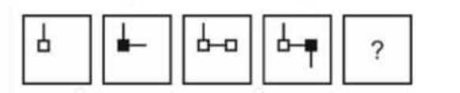
(SSC GD – 8 MAY 2026 SHIFT 2)
A.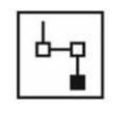
B.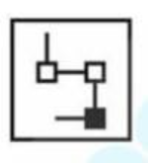
C.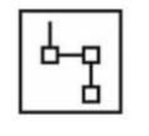
D.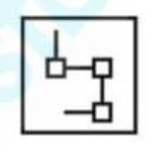
Ans:B
Exp:The Solution is
Logic:Trace the movement of the black square and the empty square:
Black square: Stays at the bottom or oscillates vertically/horizontally in a grid position. In Figure 4, it is fixed inside the lower right bend.
Lines & Flags: The structural stem bends down towards the left and then moves systematically. Following the clockwise rotating logic of the branching paths, the lines combine to form a square layout with alternating filled and unfilled ends.
Correct Answer: Option B
Subject:Reasoning > Figure Series
Difficulty:Medium
Q19.In the following figure series, select the figure which can be placed at the sign of question mark (?) from the given alternatives.
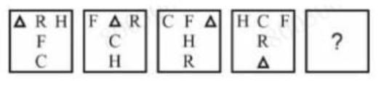
(SSC GD – 8 MAY 2026 SHIFT 2)
A.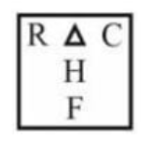
B.
C.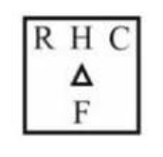
D.
Ans:A
Exp:The Solution is
Logic: Watch the position grid of the letters/shapes (Δ, R, H, F, C) across the frames:
Elements rotate positions systematically. For example, look at the triangle (Δ):
Top-Left → Middle-Right → Top-Right → Bottom-Middle.
Following this specific permutation cycle, the next frame places the letters back into the standard positions corresponding to Option A.

Subject:Reasoning > Figure Series
Difficulty:Medium
Q20.The ratio of present ages of M and S is 5 : 7. M is 6 years younger than S. What will be the ratio of M's age to S's age after 9 years?
(SSC GD – 8 MAY 2026 SHIFT 2)
A.3 : 5
B.4 : 5
C.7 : 5
D.5 : 7
Ans:B
Exp:The Solution is
- Step 1: Let their ages be 5x and 7x.
- Difference: 7x - 5x = 6 years
- 2x = 6 → x = 3
- Present age of M = 5 x 3 = 15 years
- Present age of S = 7 x 3 = 21 years
- Step 2: Add 9 years to both:
- Age of M after 9 years = 15 + 9 = 24 years
- Age of S after 9 years = 21 + 9 = 30 years
- Step 3:The new ratio:
- New Ratio = 24/30 = 4/5 → 4:5

Correct Answer: 4 : 5 (Option B)

Subject:Reasoning > Arithmetic Reasoning
Difficulty:Medium

